**Portfolio**

Name: Ulric Aird

Subject: Electronic Documentation Preparation Management

School: St. Rose Modern Secondary School

Centre: 080016

Registration #:

Teacher: Ms. Jennifer Purcell

**Table Of Content**

Two Page Block Style Letter 1

Circular Letter with Tear Off Slip 2

A Financial Report 3

Ruled Tabulation with Oblique Headings 4

A Notice of Meeting with Agenda 5

Minutes of Meeting 6

A Programme with Creative Design 7

An Organisational Chart 8

A Will 9

A Contract of Employment 10

Ulric Aird No. 1

Two pages block style letter

Ref bty/cd/4916

23rd September 2022

Benthall Pipes Limited

Water plant Section

PO Box 5

Radnor Rise

BRIGG

South Humberside

BGI 3RF

For the Attention of Mr. BT Yates

Dear Sirs

Thank you for your inquiries, reference above. We now have the pleasure of sending our quotation for FG treatment as per the attached specification sheet. The prices quoted will remain fixed for the quoted delivery period of 16 weeks and include delivery to Brigg,

For delivery at the end of January 2023 as indicated, add 2% per month for a total of 6 months. Ie 12% quoted value.

The total value of our quotation is £5,4321.75.

This quotation is valid for a period of 28 days, thereafter subject to confirmation. Delivery of the above equipment can be affected in 3-4 months from receipt of your order.

Our terms and conditions of sale are as shown on the reverse of this quotation and as per the attached addendum. VAT will be invoiced separately at the standard rate.

2

23rd September 2022

Benthall Pipes Limited

We trust that will meet your approval and look forward to receiving you instructions.

Yours faithfully

HORVELL PRODUCTS LIMITED

R F Gerard

General Sales Manager

ENCS

Ulric Aird No. 2

Circular Letter with Tear Off Slip

Edward Sleath (Publishers) Limited

Stafford House

New Castle

Staffordshire

ST5 OSW

September 27th 2022

Dear Sir

For the past two years, you have been receiving our free monthly book list and we trust you have found it of value. We are happy to continue supplying you with this list but in value of rising costs, we would be most grateful if you would indicate your wishes on the form below and return it to us.

Yours faithfully

David Steele

Circulation Manager

……………………………………………………………………………………

Title (Mr/Mrs/Ms)* ______________________________________________

Address _________________________________________________________

I would/would not* like to continue to receive copies of your monthly book list.

Signed __________________________________________________________

Date____________________________________________________________

*Delete as necessary

Ulric Aird No 3

Financial Report

**Salesman’s earning and incentive awards in the current year**

|  |  |  |  |  |  |  |
| --- | --- | --- | --- | --- | --- | --- |
| **Salesman** | **Previous Year** | **Current Year** | **Sales (Percent)** | **Increase in Awards** | **Accrued** | **Earnings** |
| Allen | 330 264 | 329 264 | 0.30 | ………. | 1 012 | 30 000 |
| Campbell | 1 129 192 | 1,380,240 | 1.5 | 3 000 | 2 224 | 88 617 |
| Duvall | ……….. | 414 656 | ……….. | ………… | ……….. | 30 000 |
| Edwards | ……….. | 419 416 | ………. | ………. | ……….. | 30 000 |
| Gatewood | 358 258 | 358 552 | 0.1 | 400(5th) | 1 104 | 18 513 |
| Hammond | 414 936 | 414 728 | ……… | ………. | 420 | 30 000 |
| Logan | ……… | 447 720 | ………. | ………. | ………….. | 30 000 |
| Mason | 645 032 | 372 392 | ……… | ……… | …………. | 30 000 |
| Samuels | 370 712 | 824 472 | 11.9 | 2 000 | 1 300 | 49 713 |
| Waters | 370 712 | 342 200 | 7.7 | ………. | 612 | 17 532 |

Ulric Aird No. 4

Ruled Tabulation with Oblique Headings

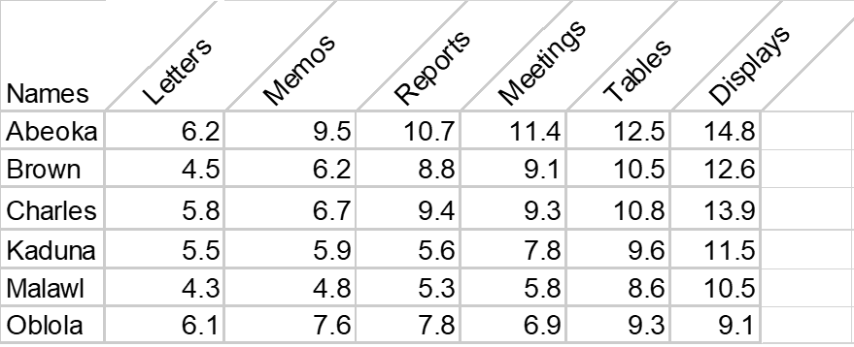

Ulric Aird No. 5

A Notice of a Meeting with an Agenda for a Meeting

EASTFIELD COLLEGE OF COMMERCE

SOCIAL COMMITTEE

OCTOBER 14TH 2022

There will be a meeting of the Eastfield College of Commerce Social Committee in the committee room on Friday 17th October 2022 at 1600 hours.

AGENDA

1. Apologies for absence.
2. Minutes of the last meeting.
3. Matter arising from the minutes.
4. Discount trading scheme.
5. Furniture for the social club.
6. Any other business.
7. Date and Time of the next meeting.

Ulric Aird No. 6

Minutes of a Meeting

MIDDLESTONE CRICKET CLUB

**Meeting No. 521**

A meeting of the committee of the Middlestome Cricket Club was held in the pavilion on October 23rd 2022.

Present

* P. Stretton [Chairman]
* R. Barnes [Secretary]
* E. Gregory
* A. Gibbon
* D.la Robe
* E. Sleath
* R. Weaves

1. Apologies Apologies were received from P Beddow and R Harvey.
2. Minutes The minutes of the last meeting held on Monday 4th

October were signed after it had been noted that Mr Harvey had been among those present.

1. Matters Arising It was reported that the front door had now been

repaired.

1. Secretary’s Report The secretary had nothing to report.
2. Wine Secretary Report Mr Bibbon reported that it had been decided to purchase

a cooling system from the draught Lager.

1. Any Other Business Mr. Weaver wants to know why cricketers were still

allowed into the tea room while wearing spikes, since this was the damaging new carpet.

1. Next Meeting the meeting closed at 2115 hours without fixing a date

for the next meeting.

Ulric Aird No. 7

A Programme with Creative Design

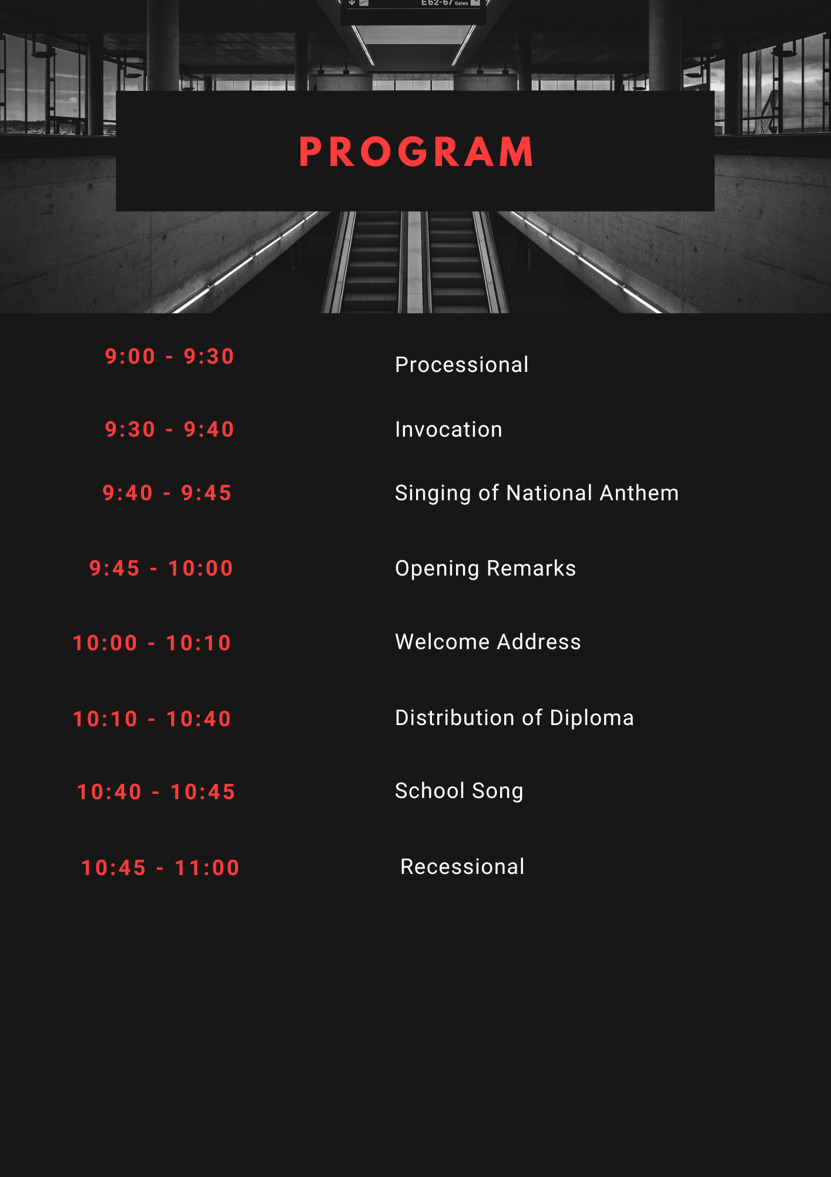

Ulric Aird No. 8

An Organisational Chat

Ulric Aird No. 9

A Will

This is the last will and testament of

Edward Sleath of 8 North Road Oxted in the county of Surrey…………..

…………………………………………………………………………………………………………………………………………………………………………

1. I revoke all former will and testamentary dispositions made by me..….

……………………………………………………………………………………

……………………………………………………………………………………

2. I appoint John Shaw, my brother-in-law of 9 Yew street Oxted………..

And Olive Jenkins of 89 Mill Street Oxted to be executor and…………

And trustees of this my will…………………………………….…………..

3. Subject to the payment of my funeral and testamentary expenses,

debts, and taxes I give and bequeath all my estate and………………..

Wheresoever to the said Olive Jenkins absolutely…………...………………….

In witness whereof have unto set my hand this (day) of two thousand and twenty-two.

Signed by the testator EDWARD STEALTH )

As and for his last will testament )

In the presence of us both being present )

At the same at his presence of each )

has hereunto subscribed our names as witnesses )

Ulric Aird No. 10

A Contract of Employment

(For the employment contract, the standard contract of the company may be used, but there should be the following main conditions).

This contract of employment is executed and entered into by and between

Employment James King

West Tennessee

Florida

444-7895

[Jamesspinking@yahoo.com](mailto:Jamesspinking@yahoo.com)

Employment Mrs. Jessica Cyrus holder of passport no.55968 of whom voluntarily binds themselves to the following terms and conditions;

Basic Terms of Contract

1. Employee job title or position assistant manager.
2. Basic monthly salary of $528.88
3. Duration of contract: the duration of the contract should not be less than two (2) years, but in special cases where salary is comparatively higher than the normal cases, a lesser duration might be considered.
4. Travelling expenses: the economic class air ticket will be provided by the employer for both ways.
5. Accommodation: the employer will provide suitable furnished accommodation free of cost. In the case of working in a community where lodging can be rented and the employer wishes to pay cash in lieu of rent suitable to the locality.
6. Food (if provided): the employer will provide three meals per day to the employees free of charge or 25% of the basic salary in lieu thereof.
7. Working days and working hours: normally working days shall be six days per week and one day holiday per week and working hours shall be 8 hours per day, 48 hours per week.
8. Overtime: in case the employer requires the worker to work overtime or holidays, the employer shall pay for overtime of holiday or holiday at 1.5 times and 12 times of basic salary rate.
9. Leave benefits: the employer shall Clearly state the weekly holidays, annual holidays, and annual holidays employer shall pay for overtime or holiday at 1.5 times and 2 times of basic salary rate.
10. Medical Treatment: the employer shall provide free medical services, including medicines.
11. Insurance: the employer shall provide the necessary insurance against death or injury according t the country of the employee.
12. Renewal of contract: the contract is renewable with mutual agreement of both the employer and employee.
13. Other terms and conditions: other terms and conditions favourable to the employee not covered herein and which the law of the country of employment provides, shall apply and form part of this contract.